PLUGGING IN

TO THE FUTURE: AN EXPLORATION OF ELECTRICITY CONSUMPTION OF PATTERNS.

# 1. INTRODUCTION:

India is the world’s third largest producer and third largest consumer of electricity. The national electric grid in India has an installed capacity of 370.106GW as of 31 March 2020.Renewable power plants which also include large hydroelectric plants, constitute 35.86% of India’s total installed capacity.

In light of the recent COVID-19 situation, when everyone has been under lockdown for the months of March to June the impacts of the lockdown on economic activities have been faced by every sector in a positive or a negative way. The dataset is exhaustive in its demonstration of energy consumption state wise.

# 1.1.OVERVIEW:

This research paper will provide an overview of the project of electricity consumption of patterns. It will begin by discussing the different types of patterns of electricity consumption, and then proceed to discussing the factors that affect electricity consumption. Finally, it will provide a conclusion on the project.

# 1.2. PURPOSE:

The purpose of this project is to investigate the effect of different patterns on the electricity consumption of a room. The specific objectives of this study are to:

* Compare the electricity consumption of a room with different patterns
* Determine the most efficient pattern for electricity consumption
* Analyze the impact of using different patterns on the environment.

# 2.PROBLEM DEFINITION & DESIGN THINKING:

# 

# 2.1: EMPATHY MAP TEMPLATE

# 2.2: BRAINSTORMING MAP TEMPLATE

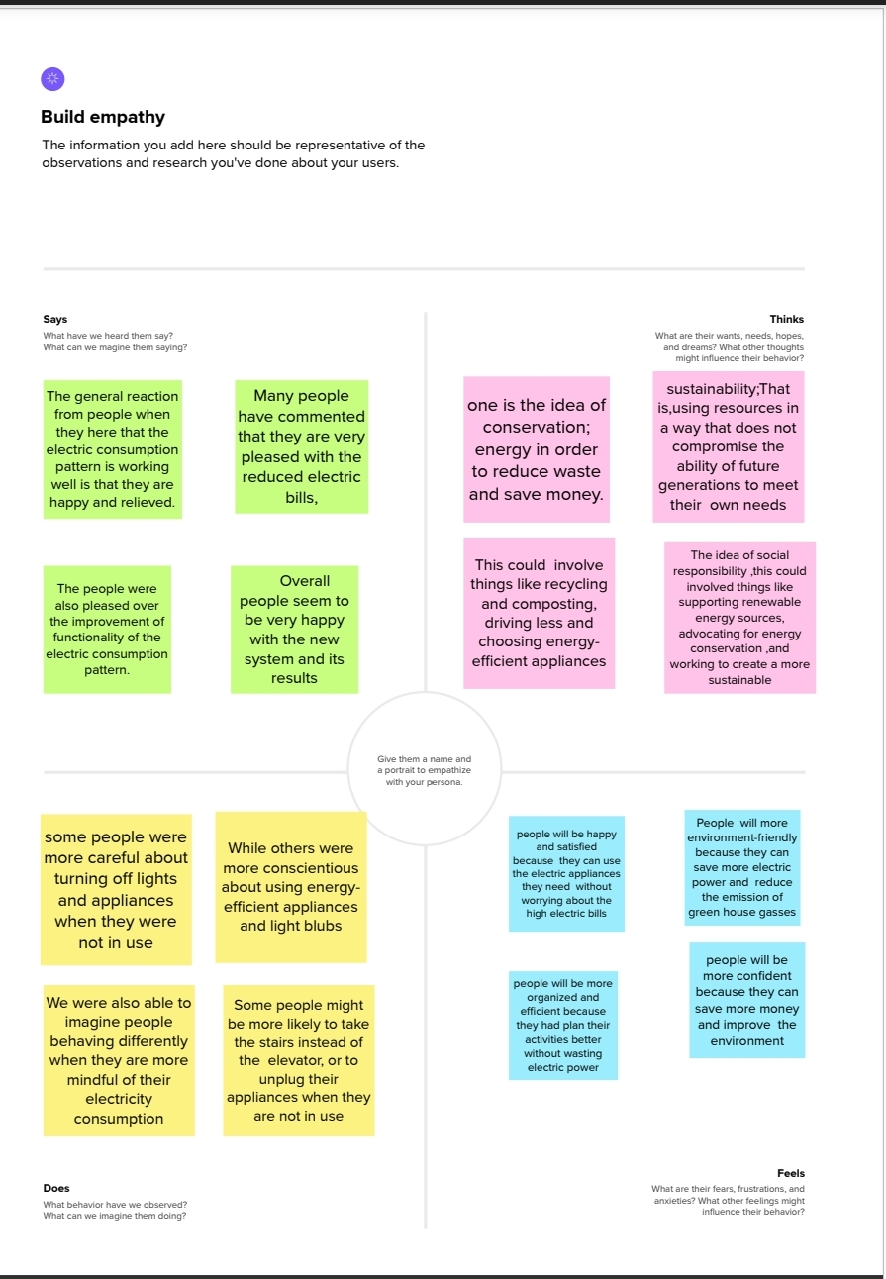

2.2: BRAINSTORM TEMPLATE MAP

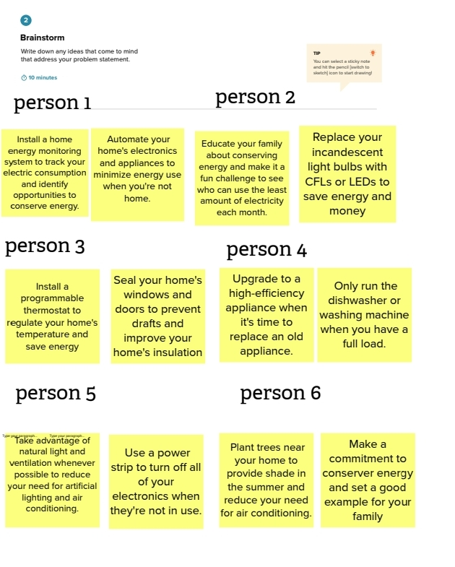

# 3.RESULT:

There are many different patterns of electricity consumption in the world. Some countries consume more electricity than others, and some use it in different ways. The united states is a country that consumes a lot of electricity. It is the number one consumer of electricity in the world. The US uses electricity for many different things, including powering homes, businesses, and transportation. Another country that consumes a lot of electricity is china. But, in the end, all of these countries need electricity to power their economies and lives.

# 4. ADVANTAGES & DISADVANTAGES OF ELECTRICITY CONSUMPTION:

# ADVANTAGES:

Electricity consumption patterns are changing. People are becoming more conscientious of their electricity use and the impact it has on the environment. Here are some advantages of the project of electricity consumption patterns;

* It helps people become more aware of their electricity use
* It helps people save money on their electricity bills
* It helps reduce greenhouse gas emissions
* It helps protect the environment.
* Electric consumption is more reliable, efficient & secure.

# DISADVANTAGES:

Electricity consumption patterns have a number of disadvantages. Here are some disadvantages of the project of electricity consumption patterns;

* The production of electricity causes air pollution. For example, the burning of coal to produce electricity releases harmful gases such as sulfur dioxide and nitrogen oxide into the air. These gases can cause respiratory problems and acid rain.
* The use of electricity can be expensive. For example, in some countries people have to pay high prices for electricity.
* The use of electricity can be dangerous. For example, if there were a power cut people can be left in the dark.

# 5.APPLICATIONS:

There are a variety of ways that the project of electricity consumption patterns can be applied. One way is to use it to help people become more aware of their own electricity consumption. Another way is to use it to help people save money on their electricity bills. A third way is to use it to help people reduce their carbon footprints.

# 6.CONCLUSION:

The project of electricity consumption patterns is now complete. We have collected data on the consumption of electricity of a variety of different objects and appliances. We have also looked at the cost of running these objects and appliances.

The results of our study show that there is a great deal of variation in the amount of electricity that different objects and appliances consume. We have also found that there is a large variation in the cost of running these objects and appliances.

In conclusion, the project of electricity consumption patterns has sown that there is a great deal of variation in the amount of electricity that different objects and appliances consume.

# 7.FUTURE SCOPE:

Electricity demand is growing rapidly all over the world. Here, the future scope of the project of electricity consumption of patterns will be discussed.

The first step in predicting future electricity demand is to understand past and current trends. Over the past few decades, there has been a steady increase in the demand for electricity. This is primarily due to the growth in population and the increasing use of electronic devices.

In conclusion, it is difficult to predict the future demand for electricity. However, it is clear that the demand for electricity is growing rapidly and that new power plants will need to be built in order to meet this demand.